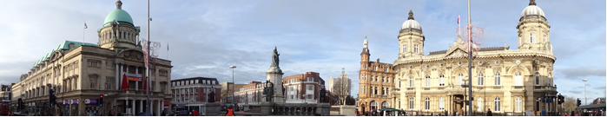
Stage Nine – Silver Street to Queen Victoria Square
Takes approximately 35 minutes

This is the final stage of our walk. From the end of Stage Eight, walk through the other end of Hepworth’s Arcade and emerge onto Silver Street. If you look across the street to the right you will see the entrance to Ye Olde White Harte again.

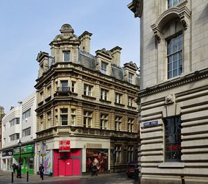
Turn left and walk to the junction in front of you. You are standing on the corner of Silver Street, The Land of Green Ginger and Trinity House Lane with Whitefriargate straight ahead. Whitefriargate was one of the main streets leading into medieval town of Hull, with Beverley Gate at the far end. It was historically a centre for commerce and banking, as you will see shortly.
From here the building you can see on the opposite corner of Silver Street is a former bank, built in 1907 and formerly offices for both the Royal Bank of Scotland and NatWest. On the corner nearest to you on the left is another bank, this time built for Barclays in 1891. Both of these ex-banks are now restaurants, but the interiors are both worth a look, if only to see how prestigious bank interiors used to be.

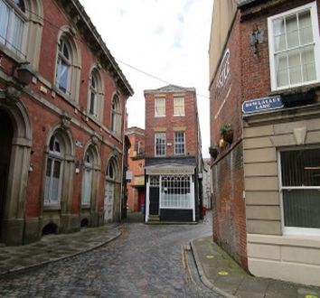
Now walk across Silver Street to the right. You are entering the famous Land of Green Ginger. There is no documentary evidence as to the origins of the name – some say it’s a corruption of the name ‘Lindegreen’, a Dutch family who lived in this area in the early 1800’s, others that it could be a corruption of the Dutch city of Groningen, still others say that this was the spice trading district of the old town. You can take your pick.

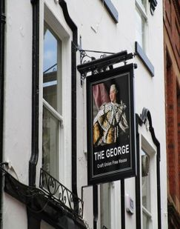
On the left, in the Land of Green Ginger, you will quickly come to one of Hull’s most historic pubs dating back to the 17th century, the George Hotel. Just before the coach entrance on the first stanchion you will see a brass plaque and to the right of the plaque is the smallest window in England. The window, it is said, was used for observing guests as they approached the hotel’s courtyard. A boy, who sat behind the small window, would identify them and allow them entry. Other accounts say it was a lookout point for excise men or even to watch out for press gangs coming. Again, you can take your pick.

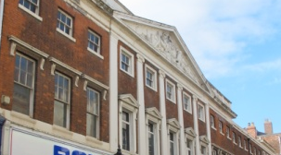
Diagonally opposite The George is an attractive 3 storey building with lanterns hanging at either side of the entrance. This was Imperial Chambers, built in 1878 as meeting rooms & library for Hull’s branch of the Law Society. It is now a city centre bar. Over the street you will see a shop that was formerly Smiths Bank, set up by a partnership between Abel Smith of Nottingham and Thomas Thompson of Hull in 1784 in the building we now know as Wilberforce House. They moved to this site when it was completed in 1830. The other parts of the building either side of the bank were originally built as elegant town houses. Smith’s Bank was absorbed into The National Provincial Bank in 1947.
Now go back to Whitefriargate and walk down about 50 metres. Fortunately this area was not touched in the World War ll bombing raids, so on the left of Whitefriargate we have an almost complete row of Georgian buildings, right down to Queen Victoria Square at the far end.

A little further on you will find two of Hull’s charities. The first, Hull4Heroes, supports ex-members of the British Armed Forces in their transition back into civilian life. The second is The Hull Peoples’ Memorial Museum which commemorates the contribution of Hull people in the services and civilians in the two world wars. It is run entirely by volunteers. Walk a little further to the corner of Parliament Street. On the corner is a large four story stone building which was built in 1879 as the HSBC bank. It closed its doors early in 2017.

Now turn and look at the building behind you, still on Whitefriargate. You will see the magnificent one-time Neptune Inn, built in 1795, just a few years after the Hull’s first dock was built.
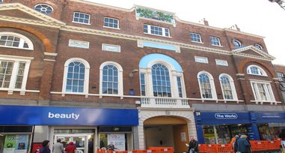
There is a coaching archway with the keystone depicting the head of Neptune. Above that are 7 bays with Venetian style windows and on the roof line is a pediment with a brightly-coloured centre panel. The shield bearing an inverted anchor you can see in the centre is the coat of arms of Trinity House – you may have spotted this badge in several places along the Hull Heritage Walk, as a lot of property around here belongs to, or formerly belonged to, the Trinity House shipping authority.
The original idea of the Neptune Inn was to cater for people of substance travelling between London and Scotland or York. It would be easier and safer to travel by sea with a stop off in Hull rather than take on the hazardous journey by coach, with terrible roads and the possibility of highwaymen. However, these were difficult times in Britain due to the ongoing Napoleonic Wars and the expected rents could not be met, so unfortunately the inn closed in the early 1800’s. It became Hull’s Customs House in 1815 and remained so until 1912. On the wall to the left of the archway is Hull’s oldest post box, stamped with the letters VR for Queen Victoria.

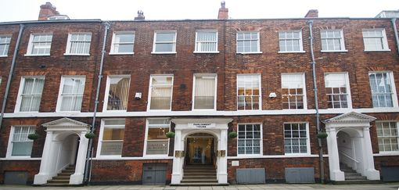
Looking back across the road from the Neptune Inn is Parliament Street, an almost complete Georgian Street. It was built at the same time as the Neptune Inn and formed a direct link between it and the dock it was planned to serve. An Act of Parliament was needed to acquire the land and hence the named Parliament Street. In 1861 the Builder magazine described it as ‘a snug little street full of attorneys, notaries, registrars and accountants’, and you will see as you walk down the street not very much has changed.
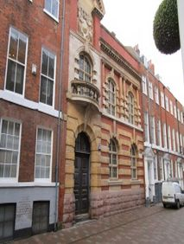
Walk down Parliament Street. On the left, you will pass the exception to the Georgian frontages, the Edwardian Police Station. It is the building with the stone balcony, completed in 1904 in a baroque style. It was in use until the 1950s when the central Police Station was moved to a large building on the other side of Queen’s Gardens, which has itself been converted into an apartment block called The Glass House.

Before you cross look to your right and you will see the west end of The Guildhall. From here you get an excellent view of the building and the wonderful statue of the River Goddess, shown at the bow of a boat being drawn by seahorses.

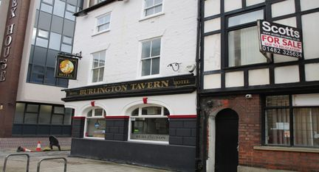
Behind you to your right and on the corner of Manor Street is Burlington Tavern. This used to be a dockside pub, but of course, there’s no dockside now. Cross over the street and turn left, then almost immediately turn right and you will be on Quay Street facing Queen’s Gardens. Walk down Quay Street.

As you walk down Quay Street towards Queen’s Gardens you will cross Hanover Square and then find, on your right, a memorial to people from our area who fought with The International Brigade during the Spanish Civil War (1936-1939). Their names, including those of four who died can be found around the sculpture. The Memorial was unveiled on 16th March 2019 and financed by donations from individuals and organisations. Hull International Brigade Memorial Group was formed in 2016. The sculpture is made of Spanish marble and steel from Catalonia and was made by Dan Jones, a Yorkshire artist. There is also a memorial plaque in the City Hall.
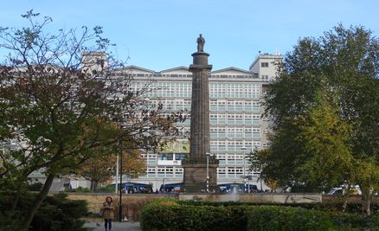
Hanover Square and Guildhall Road are both one way, so please look to your right here. The fact that the garden is sunken reminds us of its previous existence as a dock, and the outline of the basin is clear in the low walls and wide surrounding streets. Queen’s Gardens, once Queen’s Dock, is undergoing extensive renovation at the present time.
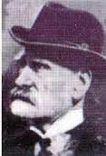
Take a moment to look right at the monument to William Wilberforce but then turn left along Guildhall Road in the direction of Victoria Square.
Not too far from this spot Ebenezer Cobb Morley, the founding father of association football was born in 1831 and grew up on the streets around the north side of Queen’s Docks.
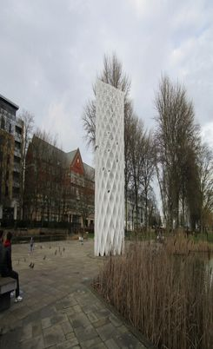
As you walk past Queen’s Gardens you will be able to see, in the gardens, ‘The Cheese Grater’, properly entitled The Solar Art Work. In three years time, when the work is finished it will be possible to investigate the Cheese Grater.
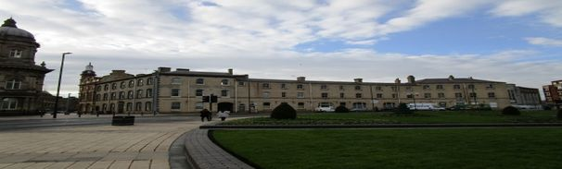
At the end of the garden is a fountain area, recently named ‘The Rose Bowl’. It too is fenced off at present but look across the fountain and there is The Maritime Museum, also undergoing renovations but is expected to reopen in 2025. Turn right and walk round the fountain. On the right you will pass first the BBC Building and then The Warren, an institution dedicated to the service of young people in the city. It is housed in Dock Office Chambers, built in 1872 for the Hull Dock Company. Note the archways that led to the stables in the internal courtyard.
Continue a little way more to the light controlled crossing. This will point you in the direction of New Cross Street between the Maritime Museum and the Warren, which will take you back to Victoria Square, which is where stage one began and where we will finish the Hull Heritage Walk.

You may still have time to visit The Ferens Art Gallery, if it’s open. There a cafe in the art gallery but check the closing time. It can surprise you.

End of Stage Nine

